## Creating an Azure VM with PowerShell

### Lab Overview

In this lab, you will next configure a PowerShell script that will deploy a second virtual machine in the same availability set as the first virtual machine for a second web server. The script will also deploy a virtual machine using a SQL Server image that will later be used to host a database.

### Exercise 1: Deploy VMs via PowerShell

1. Launch the PowerShell Integrated System Environment (ISE)by **right-clicking** on the **Start** button and choosing **Run**

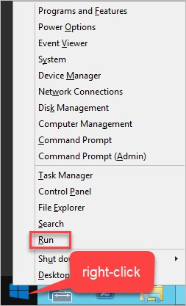

1. Launch the PowerShell Integrated System Environment (ISE) by typing in **PowerShell_ISE** in the Windows run prompt.

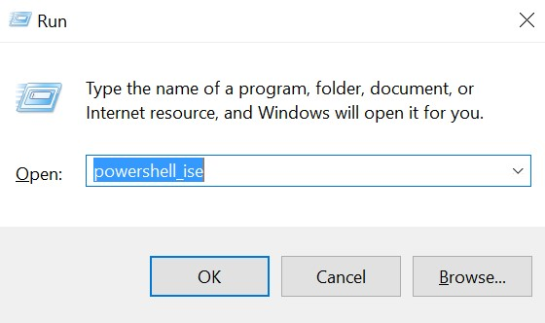

1. Within the ISE, click the Folder icon on the toolbar, and Navigate to C:\OpsgilityTraining. Click the **create-azure-vm.ps1** script to open in the editor.

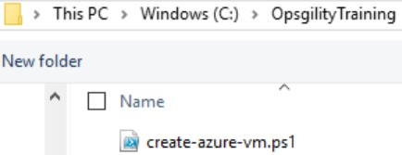

1. Review the comments of the script to get a better understanding of how the script works.
2. In the **PowerShell ISE Console Pane** run the **Login-AzureRmAccount** cmdlet by typing the cmdlet name in and pressing **Enter**. This cmdlet will launch a dialog that will allow you to login with your Azure subscription credentials. The session is valid for 12 hours as long as you do not close and re-open the PowerShell ISE.

Login-AzureRmAccount

1. Enter the credentials for your Azure subscription when prompted.

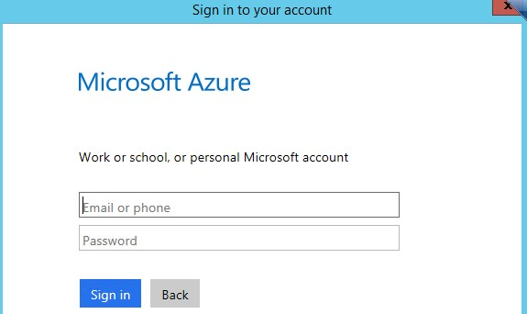

1. In the **PowerShell ISE Console Pane** run the following command to list the subscriptions that are attached to your account.

Get-AzureRMSubscription

The return from Azure will look like the follow. Make note of the SubscriptionID that matches the subscription you used earlier in the lab.

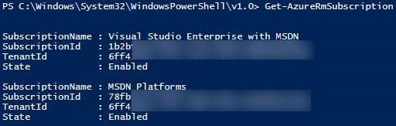

1. In the **PowerShell ISE Console Pane** run the following command to Select the subscription that will be used for the reminder of the course. Replace [subscription id] leaving the quotes.

Select-AzureRmSubscription -SubscriptionId "[subscription id]"

1. In the **PowerShell ISE Console Pane** run the following command to persist your credentials to a **.json** file. This will allow you to open up multiple sessions within ISE or close and reopen the ISE. The authentication credentials are valid for 12 hours.

Save-AzureRmProfile -Path C:\WiproTraining\WiproTraining.json

1. Create a variable called $rgName assigned to the name of the resource group your first virtual machine was created in by typing the following in the Console Pane and pressing **Enter**.

$rgName = "OpsVMRmRG"

1. Identify the name and Azure region (location) of the Azure Storage Account the first virtual machine is using by executing this command in the Console pane.

Get-AzureRmStorageAccount -ResourceGroupName $rgName

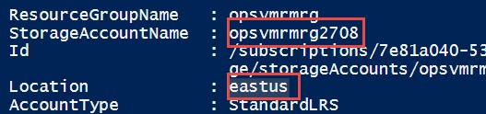

1. Update the **$saName** and **$location** variables in the **create-azure-vm.ps1** script with the name of the storage account and the region.

Example change:

$saName = "[unique storage account name]"

$location = "[azure region name]"

to

$saName = "opsvmrmrg2708" $location = "eastus"

1. You will need a unique DNS name for the VM we will create with PowerShell. Determine a name that will probably be unique, such as “testwebvm00002”. Use the following command below to test for the availability of the DNS name. If the code returns **True** it means the name is available. If it returns **False** the name is not available and you should try again with a different name.

Test-AzureRmDnsAvailability -DomainNameLabel "[unique DNS name]" -Location "[the location of your storage account]"

Example execution:

Test-AzureRmDnsAvailability -DomainNameLabel "opsweb010100" -Location "eastus"

1. Store the value of the unique DNS name in a variable by replacing the placeholder value that is assigned to the $dnsName variable in the script.

Example change:

$dnsName = "[unique DNS name]"

to

$dnsName = "opsweb010100"

1. Execute the script by clicking the green arrow on the tool bar.

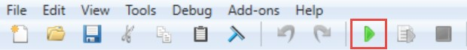

1. The PowerShell ISE will prompt you that the file will be saved.

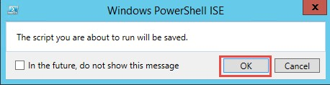

1. Next PowerShell ISE will request that you enter the credentials to be used with the new VM.

Use the same credentials as you did for WebVM-1

a. User Name: **demouser**

b.

Password:

**demo@pass123**

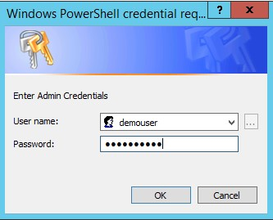

1. Monitor the console screen to follow the status of the VM creation (process takes 8~15 minutes).

### Lab Summary

In this lab, you configured a PowerShell script that deployed a second virtual machine in the same availability set as the first virtual machine. The script also deployed a virtual machine using a SQL Server image that will later be used to host a database.